Inside This Issue:

Trick or Treat?
……........... 1

Fall Festivals In Full Swing
……........... 2

Improve Indoor Air Quality With These Common Plants ..................... 2

Lite Friday Nights
.................... 3

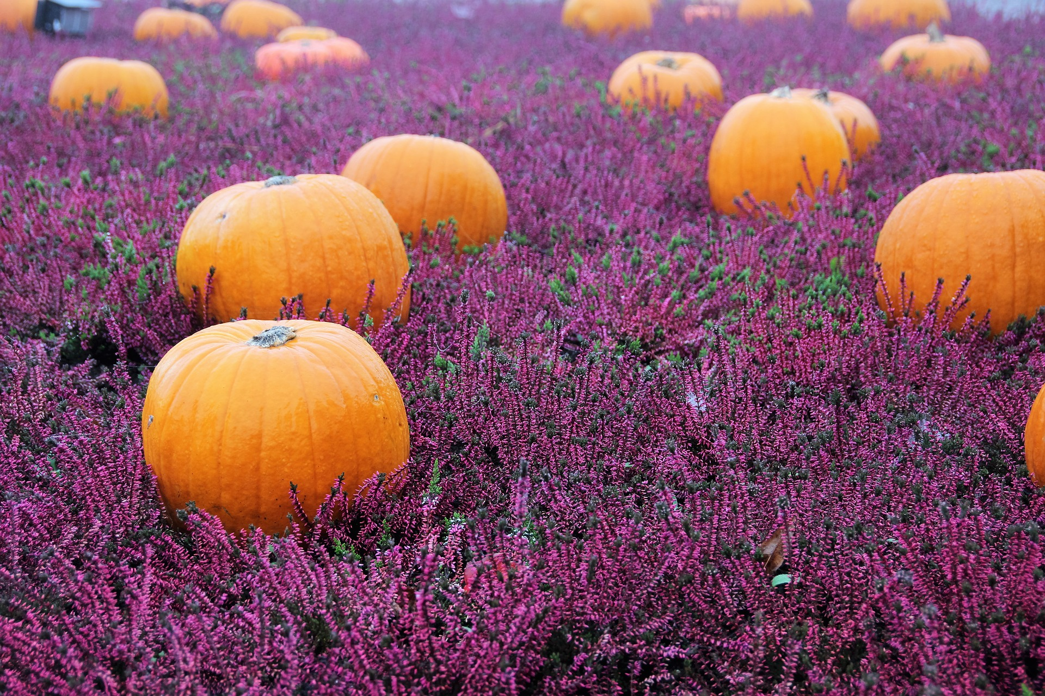

The Season for Pumpkin Spice Is Upon Us
.....................3

It Happened In October
………..…….4

Tax-Loss Harvesting: 2017 Considerations
………..…….4

Your Retirement
“News You Can Use”

Retire Village Volume 5, Issue 10, October 2017

Trick or Treat?
Although it is unknown precisely where and when the phrase “trick or treat” was coined, the custom had been firmly established in American popular culture by 1951, when trick-or-treating was depicted in the Peanuts comic strip. In 1952, Disney produced a cartoon called “Trick or Treat” featuring Donald Duck and his nephews Huey, Dewey and Louie.

In Scotland and Ireland, young people took part in a tradition called guising. They dressed up in costume and would sing a song, recite a poem, tell a joke or perform another sort of “trick” before collecting their treat, which typically consisted of fruit, nuts or coins.

In the mid-19th century large numbers of new immigrants, especially those fleeing Ireland’s potato famine in the 1840s, helped popularize Halloween.

With the outbreak of World War II, children had to refrain from trick-or-treating because of sugar rationing.

At the height of the postwar baby boom, trick-or-treating reclaimed its place among other Halloween customs, quickly becoming standard practice for millions of children in America’s cities and newly built suburbs.

No longer constrained by sugar rationing, candy companies capitalized on the lucrative ritual, launching national advertising campaigns specifically aimed at Halloween.

Today, Americans spend an estimated $6 billion annually on Halloween, making it the nation’s second-largest commercial holiday.

http://www.history.com/topics/halloween/history-of-trick-or-treating

Fall Festivals
In Full Swing

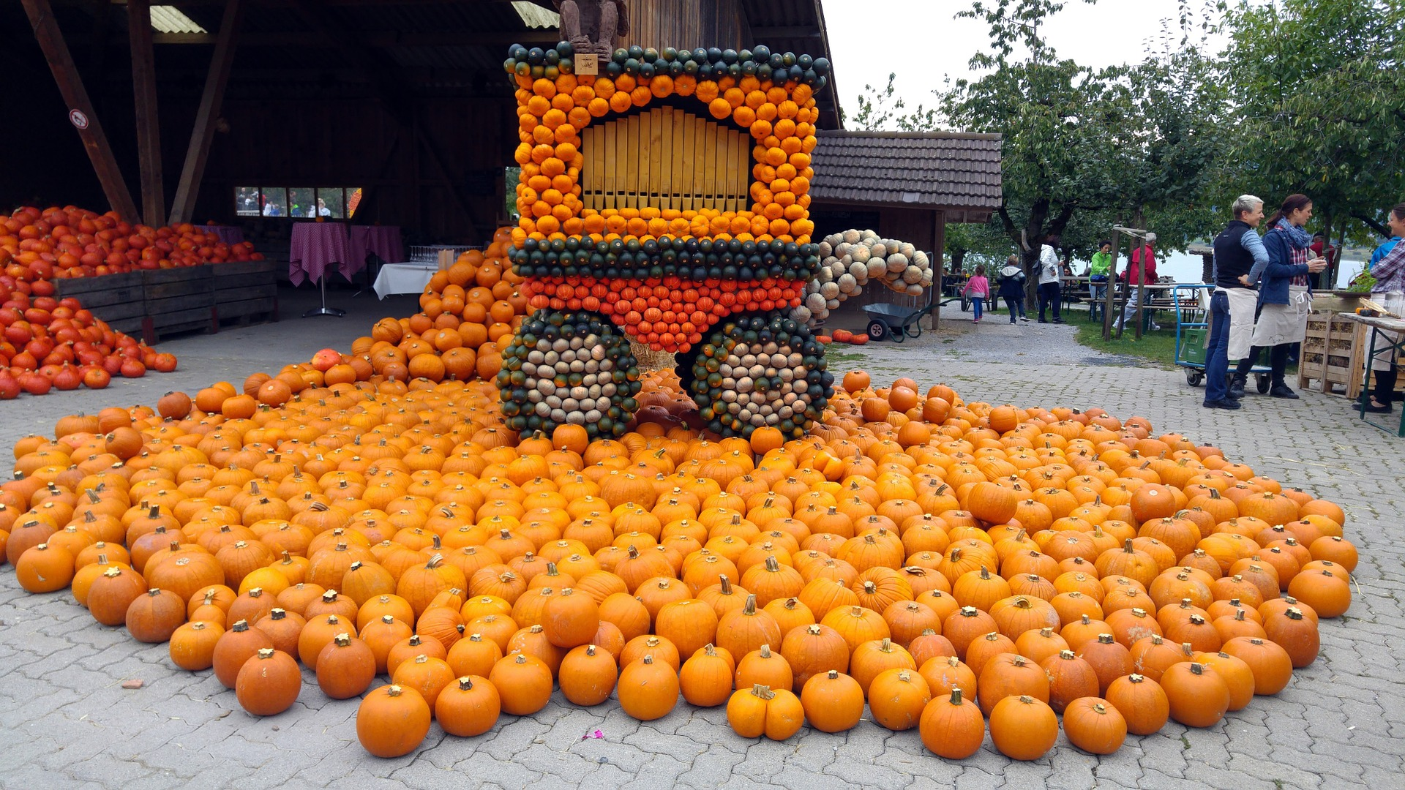

October 18-21, 2017
Circleville, Ohio Pumpkin Show features parades and delicious fall treats. Plus, more than 10,000 pounds of pumpkins, squash, and gourds decorate buildings and line the streets!
- pumpkinshow.com

October 4-8, 2017
Sun Valley, Ketchum, and Hailey, Idaho celebrate the “Trailing of the Sheep” from the mountains to their winter pasture.
- trailingofthesheep.org

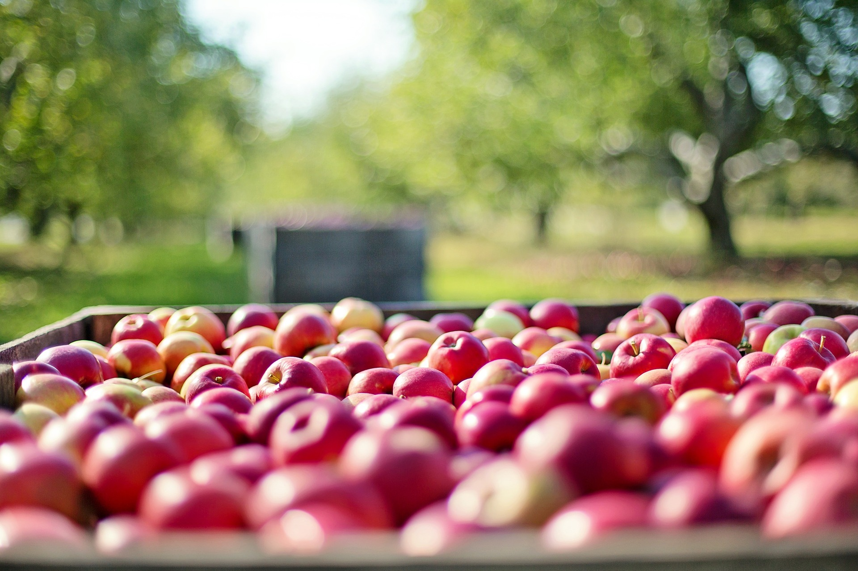

October 7-8 & 14-15, 2017
The National Apple Harvest Festival in Arendtsville, Pennsylvania is a total dream come true for anyone who loves apple picking season.
- appleharvest.com

Improve Indoor Air Quality
With These Common Plants

Modern home and office furnishings are composed of synthetics and conventional construction materials containing many glues and resins which can substantially degrade indoor air quality.

Formaldehyde, one of the most pervasive chemicals used in modern furnishings and construction materials, is emitted from adhesives, sealants, ceiling tiles, carpets, upholstery, paints, and particle board. Other common chemicals found in our interior air are toulene, benzene, ammonia, and acetone.

The proliferation of electronic devices in use today also emit many of the same volatile organic chemicals which can contribute to allergies, asthma, fatigue, headache, respiritory and sinus congestion, and irritated eyes.

Symptoms increase during the cold months when we spend more of our time inside.
Azaleas lend color to our indoor environments and are in the top 14 houseplants that

absorb a wide variety of toxins from the air.
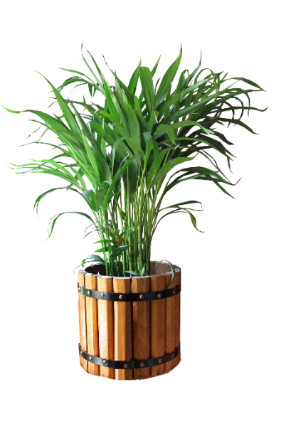Three house-sized members of the palm family are the top rated for the removal of airborne VOC’s.

The Areca Palm, Lady Palm, and Bamboo Palm show the highest rates of formaldehyde removal of 50 common houseplants studied. They also boast high transpiration ratings, providing much needed moisture during winter months when our heating systems dry out indoor air.

Rubber Plant, English Ivy, Ficus, Boston Fern, Peace Lily, Corn Plant, and Florist’s Mum are also very effective at removing chemical vapors and produce sufficient transpiration rates to moisturize dry indoor air.

How to Grow Fresh Air – 50 Houseplants that Purify Your Home Or Office, by Dr. B.C. Wolverton

Lite Friday Nights

Whether for tailgating fans or refueling your team after practice, some well-chosen and delicious game day snack options will keep everyone happy and healthy this season.

Greek yoghurt instead of sour cream: Try stirring a spoonful or two of ranch dressing mix or blue cheese crumbles into Greek yogurt for a tasty protein packed dip – instead of chips, serve with plenty of chilled broccoli and cauliflower florets, sliced sweet peppers, celery, and carrot sticks. Also great with grilled or oven roasted beets, yellow squash, zucchini, red potatoes, or sweet potatoes.

Slow cooked soups are easy, nutritious, and convenient for large game-day crowds: A slow cooker of chili or navy bean soup is an easy and adaptable option to satisfy your group. Extra veggies, like peppers, celery, onions, winter squash, and tomato, can add even more flavor and nutrition.

Substitute leaner meat options such as ground turkey instead of ground beef and whole grain buns:
Sloppy Joes and burgers can become a much healthier option by making these two small changes.

The Season for
Pumpkin Spice Is Upon Us

to Stay

Upbeat all Season

Warm and comforting, aromatic pumpkin spice has gained increasing attention as the cold weather flavor for cereal, coffee drinks, specialty beers, and many popular seasonal snacks throughout the fall and winter months.

Many pumpkin spice flavored products on the market today may be made with artificial ingredients and a whole bunch of extra sugar instead of the true spices. For purists, pumpkin pie spice is easy to make. You can even adjust the formula to suit your taste: extra cinnamon and nutmeg, or reduced ginger and cloves.

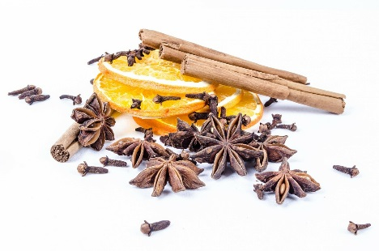
Basic Pumpkin Spice Recipe:

1 tbsp. ground cinnamon
2 tsp. ground ginger
1/2 tsp. allspice
1/2 tsp. ground cloves
1 tsp. ground mace or nutmeg

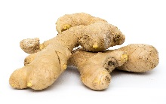
Whisk together the above ingredients and store in a sealed container for up to 6 months.

Pumpkin Spice is not just for flavoring Pies & Cakes.

Sprinkle a bit of pumpkin spice into your Jack-O-Lantern before lighting the candle, and delicious holiday aromas will result.

Mix equal portions of brown sugar and pumpkin spice to sprinkle over buttered popcorn or mix in with oven roasted nuts for a sweet and salty snack.

Add pumpkin spice to the sugar and vanilla normally included in homemade whipped cream for the perfect accent to hot buttered rum or coffee drinks, apple crisp or dumplings, tarts, cakes, gingerbread, apple pies, and baked pears.

Pumpkin spice can also add a seasonal twist to your breakfast. Substitute a generous amount of pumpkin spice for the cinnamon that you would add to your morning oatmeal or homemade breakfast granola recipe.
It Happened In …

October 8th 1871 –
The Great Fire of Chicago, allegedly started by Mrs. O'Leary's cow, killed over 300 people and leveled 3.5 square miles, destroying 17,450 buildings. Financial losses totaled over $200 million and 90,000 were left homeless.

October 19th 1987 –
"Black Monday" occurred on Wall Street as stocks plunged a record 508 points or 22.6 per cent, the largest one-day drop in stock market history.

October 25th 1881 –
Pablo Picasso, a painter, sculptor, engraver and ceramist was born in Malaga, Spain.

October 30th 1938 –
The War of the Worlds radio broadcast with Orson Welles and the Mercury Players dramatized the story by H.G. Wells about a Martian invasion of New Jersey. Their script used simulated news bulletins which many listeners thought were real.

http://www.historyplace.com/
specials/calendar/september.htm

Tax-Loss Harvesting:
2017 Considerations
Selling losers to offset winners.
Tax-loss harvesting means taking capital losses (selling securities worth less than what you first paid for them) to offset the short-term capital gains you have amassed.
While this doesn’t get rid of your losses, it can mean immediate tax savings. It can also help you diversify your portfolio and position yourself for better long-term, after-tax returns.
Identify all of the “losers” in your portfolio and then determine which losers to sell in order to balance out your net gain.
You can use this loss harvesting to balance out your net gains at $0, and in addition up to $3,000 of capital losses beyond your capital gains can be deducted annually. Any remaining capital losses above that can be carried forward to offset capital gains the following year.¹
You can only practice tax-loss harvesting in taxable accounts; tax-advantaged

accounts are ineligible for this strategy.
Be aware that the wash-sale rule applies to your entire taxable portfolio and multiple taxable accounts – worth remembering if you and your spouse file your taxes jointly.²

Some investors harvest losses throughout the year, not just in December.
Taking a bunch of losses this year, and carrying over the excess losses into next year allows you to potentially shelter some or all of your long-term and short-term capital gains next year. This gives you a chance to shelter winners you’ve held from being taxed.

1 – http://smartasset.com/taxes/all-about-tax-loss-harvesting

2 – http://thebalance.com/wash-sale-rule-3192972

