Inside This Issue:

Get Ready For Spring Road Trips ……........... 1

Spring Quotes .............. 2

Will 2017 Be The Year Inflation Makes A comeback? .............. 2

Celebrate Saint Patrick’s Day .....................3

The IRS “Dirty Dozen” highlights various schemes that taxpayers may encounter anytime, many of which peak during tax-filing season .....................3

It Happened In March
………..…….4

Is your yard attractive from a bird’s eyes? …..4

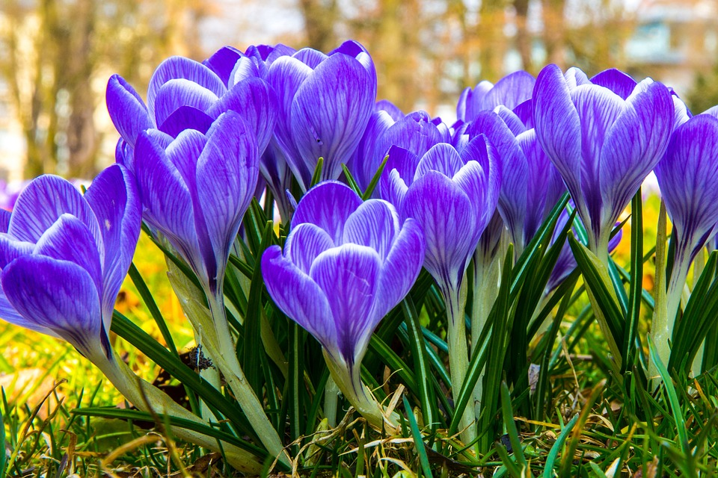

Your Retirement
“News You Can Use”

Retire Village Volume 5, Issue 3, March 2017
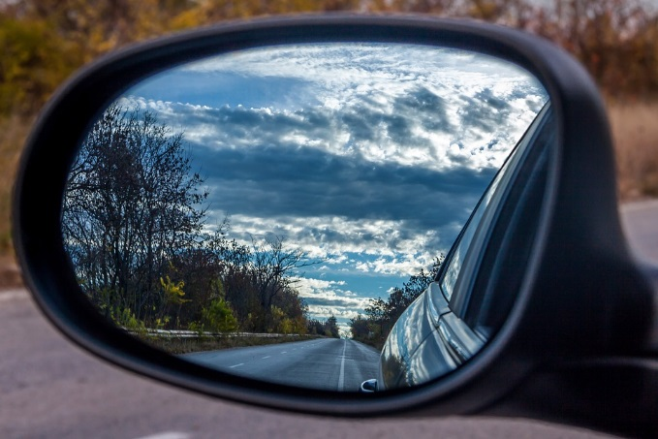
Get Ready For Spring Road Trips
Spring is just around the corner and soon we will see milder temperatures, less rain and snow, and heed the call of the open road. Make sure your car is in tip top condition for your Springtime driving.
1. Thoroughly clean your car’s exterior to get rid of any salt, sand, and dirt buildup.
2. Check your tires - apply lubricant to the threads of the lug nuts to prevent them from getting stuck in case you need to change a flat tire.
3. Inspect your brakes - if you see rust flaking from your brake pads or any cracks in the braking material or hoses, visit a mechanic for a proper brake check.
4. In winter, moisture can build up in your vehicle’s interior—especially in older cars or vehicles parked outside. Removing this moisture prevents mold, corrosion, and electrical system damage.
5. Inspect your oil to make sure that it’s an amber color.
6. Keep your antifreeze levels full year-round not only to prevent your cooling system from freezing but also to stop corrosion, lubricate the water pump, and raise the boiling point of the water.
7. Inspect all of your car’s other fluids—like transmission, power steering, brake, and windshield washer fluids.
8. Your car’s battery is a crucial component in keeping your car operating at its best. If you have an AAA membership, you can schedule a free battery, starter, and electrical test at your location.
9. Make sure windshield wipers, inside and outside lights, and air conditioning are functioning properly.

https://www.aaa.com/2017/02/9-tips-to-get-road-trip-ready-for-spring/ This is the year inflation worries could begin to simmer for the first time in ages. Consumer prices surged 0.6% in January from December, double the consensus forecast of a 0.3% rise. This marks the sharpest monthly increase since February 2013, according to the Bureau of Labor Statistics. In its 2017 outlook, Charles Schwab pulled inflation to its "front burner" list of concerns for stocks and pushed deflation to its "back burner." ¹
Will 2017 Be The Year Inflation
Makes A Comeback?
5 Easy Ways to Stay Sharp Forever

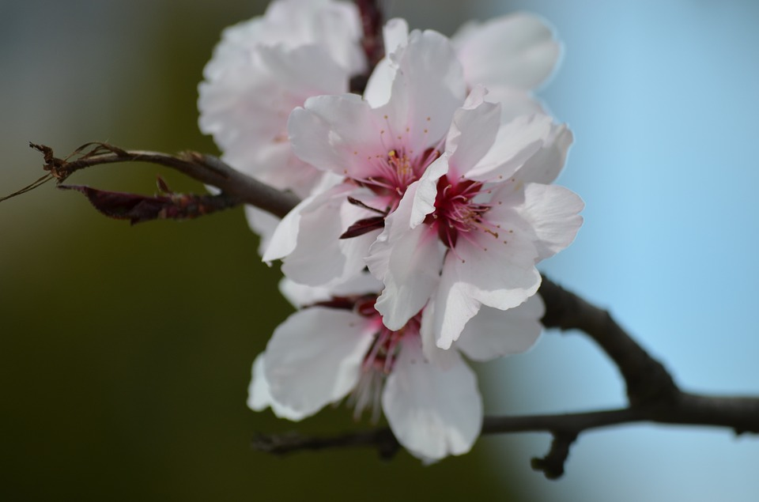

“In the spring I have counted one hundred and thirty-six different kinds of weather inside of four and twenty hours. "
- Mark Twain

Every Spring, God rewrites the Book of Genesis.
- Unknown

" In the spring, at the end of the day, you should smell like dirt."
- Margaret Atwood

" No matter how long the winter, spring is sure to follow."
- Proverb

" Indoors or out, no one relaxes in March, that month of wind and taxes, the wind will presently disappear, the taxes last us all the year."
- Ogden Nash

“To be interested in the changing seasons is a happier state of mind than to be hopelessly in love with spring.”
- George Santayana

" Spring has returned. The Earth is like a child that knows poems."
- Rainer Maria Rilke

www.quotegarden.com/spring.html

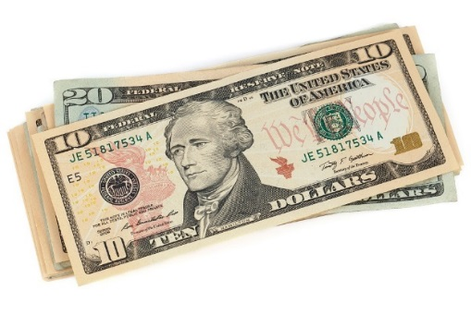
Steven Wieting, global chief strategist at Citi Private Bank, expects President-elect Donald Trump's plans for fiscal stimulus and tax cuts to boost GDP by more than a full percent this year. But those programs should also bring some inflation. ¹

You’ll need to be especially aware of inflation in the following areas: Medical costs are on the rise, and they’re significantly outpacing CPI inflation averages. In retirement, you’re likely to need more medical care than you do at a younger age, so

carefully consider medical inflation as you plan for retirement.
Food costs can be volatile. For example, dairy, beef and grains have seen pricing spikes in recent years due to factors such as drought, livestock illnesses and changing farming practices. Expect more of the same in the future.
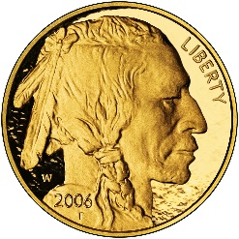
Gold is off to a strong start in 2017, much like the strong start in 2016; in February delivery closed up 0.5% as some investors bet that the strengthening U.S. economy will bring inflation in the new year. ²

But the interesting thing in 2017 is that gold is holding up this time around despite increased odds of a March FED rate hike. So, on the one hand gold should be dropping on increasing rate hike expectations, but on the other
hand the spike in inflation is supporting the gold price. ³

1 - http://www.cnbc.com/2017/01/05/2017-is-the-year-inflation-makes-a-comeback-and-donald-trump-could-play-a-role.html
2 - https://www.wsj.com/articles/gold-prices-rise-as-investors-bet-on-inflation-1482855487
3 - http://www.gold-eagle.com/article/inflation-spikes-2017%E2%80%A6supporting-gold-prices-despite-increased-odds-march-rate-hike

The IRS “Dirty Dozen” highlights various schemes that taxpayers may encounter anytime, many of which peak during tax-filing season.

to Stay

Upbeat all Season

Celebrate Saint Patrick’s Day!

Since around the ninth or 10th century, people in Ireland have been observing the Roman Catholic feast day of St. Patrick on March 17th.

More than 100 St. Patrick's Day parades are held across the United States - New York City and Boston are home to the largest celebrations.

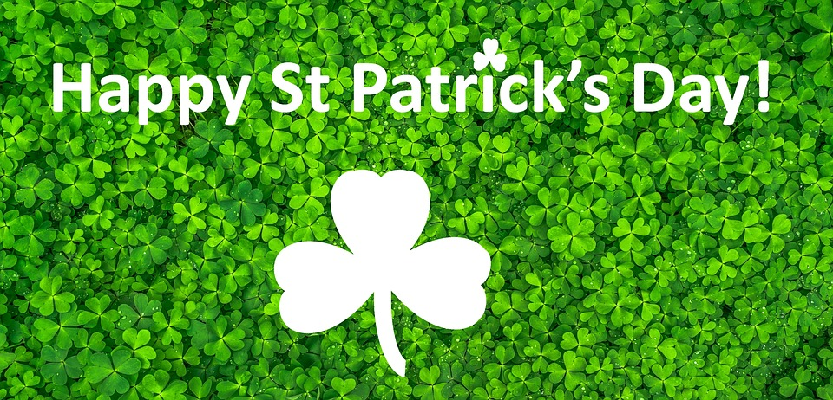

Leprechauns are considered the only faerie to have a trade which is that of shoe-making. The famous Irish writer and poet, W.B. Yeats is quoted as saying because they dance so much, leprechauns are always in need of new shoes.

Chicago’s annual dyeing of the Chicago River green started in 1962. That year, they released 100 pounds of green vegetable dye into the river–enough to keep it green for a week! Today, in order to minimize environmental damage, only 40 pounds of dye are used, and the river turns green for only several hours.

http://www.history.com/topics/st-patricks-day/history-of-st-patricks-day

Watch out for the following scams that steal personal information, scam you out of money, and avoid any questionable behavior in filing your taxes.

Phishing: The IRS will not contact taxpayers via email about tax bills or refunds. Don’t click on emails or fake websites claiming to be from the IRS.

Phone Scams: The IRS has seen a surge of phone scams in recent years as con artists threaten taxpayers with police arrest, deportation and license revocation if they do not make payment immediately.

Identity Theft: The IRS aggressively pursues criminals that file fraudulent returns using someone else’s Social Security number, but taxpayers still need to be extremely cautious and do everything they can to avoid becoming victimized.

Also make sure your preparer and charities are legitimate.

Inflated Refund Claims: Avoid preparers who ask you to sign a blank return, promise a big refund before reviewing your records or charge fees based on a percentage of your refund.

Excessive Claims for Business Credits: Avoid misuse of the research credit and the fuel tax credits.

Falsely Padding Deductions on Returns: Claiming false income can lead to taxpayers facing large bills to pay back taxes, interest and penalties.

Abusive Tax Shelters: The IRS is committed to stopping complex tax avoidance schemes and the people who create and sell them.

Frivolous Tax Arguments: Think twice before taking advice to make a frivolous claim. The penalty for filing a frivolous tax return is $5,000.

Offshore Tax Avoidance: The recent string of successful enforcement actions against offshore tax cheats -- and the financial organizations that help them -- show that it’s a bad bet to hide money and income offshore.

https://www.irs.gov/uac/irs-recaps-dirty-dozen-list-of-tax-scams-for-2017
Is your yard attractive
from a bird’s eyes?
It Happened In …
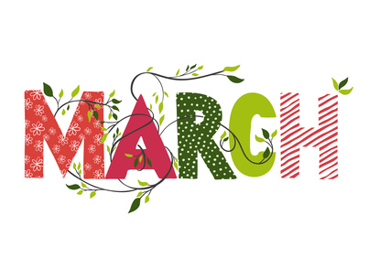

March 1st 1961 –
President John F. Kennedy established the Peace Corps.

March 10th 1862 –
The first issue of U.S. government paper money occurred as $5, $10 and $20 bills began circulation.

March 15th 44 BC – Julius Caesar was assassinated in the Senate chamber in Rome by Brutus and fellow conspirators… Beware the Ides of March!

March 27th 1977 – The worst accident in the history of civil aviation occurred as two Boeing 747 jets collided on the ground in the Canary Islands, resulting in 570 deaths.

March 31st 1991 –
The Soviet Republic of Georgia, birthplace of Josef Stalin, voted to declare its independence from Soviet Russia.

http://www.historyplace.com/specials/calendar/march.htm

The songbird breeding season - mid-March through August - is a critical time for both resident and migratory birds in the United States, and your yard can provide much needed shelter and nourishment – in exchange, you can expect exuberant feathered visitors.

Provide Nesting Sites

Plant a variety of native shrubs and trees in multi-species clumps. A mosaic design - where species are overlapped and grown in clumps - mimics natural plant communities and, therefore, provides the best nesting habitat for birds.
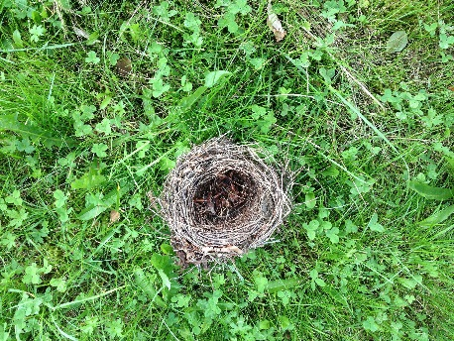
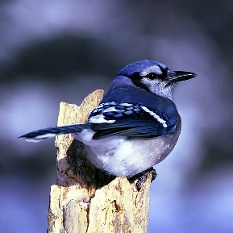
Mow Smart
Many songbirds nest close to the ground in grasses and ‘weedy’ areas. Critical nesting habitat and even nests can be destroyed by mowing and routine yard maintenance. Set aside “no-mow” areas of your land, this will provide nest sites and shelter for several bird species, especially goldfinches, buntings, quail, and towhees.

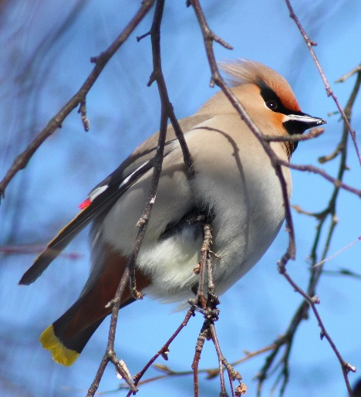
Leave Dead Trees or Limbs
If dead trees or limbs do not pose a hazard, try to keep them in your backyard landscape. Natural cavities provide better nest sites than bird boxes.

Leave Brush Piles and Grass Clippings
Brush and grass piles provide shelter, nesting material, foraging grounds, and even nesting sites for birds. Set aside an area of your yard that you can leave cut branches and grass clippings undisturbed throughout the season.

Some ground nesting insects, such as Bumble Bees, may also set up housekeeping.

http://www.prbo.org/cms/docs/edu/Backyard_hab.pdf

