Your Retirement
“News You Can Use”

Retire Village Volume 5, Issue 2, February 2017
Groundhog Day 2017: Punxsutawney Phil Sees Shadow, Predicts 6 More Weeks of Winter

Inside This Issue:

Groundhog Day 2017: Punxsutawney Phil Sees Shadow, Predicts 6 More Weeks of Winter
....................... 1

Love Quotes
....................... 2

Age-Proof Your Brain: 5 Easy Ways to Stay Sharp Forever ....................... 2

Don’t Forget To Review These Items When You Meet With Your Adviser. .....................3

Closing The Bank Of Mom And Dad .....................3

It Happened In February
………..…….4

Extraordinary Uses for Ordinary Things: Nail Polish Remover
………..…….4

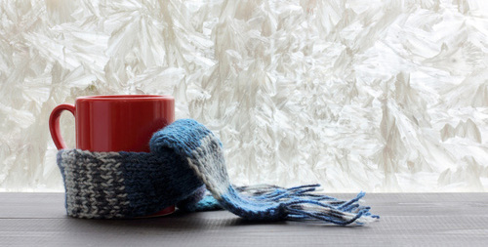

Punxutawney Phil saw his shadow on Thursday morning, predicting six more weeks of winter during Groundhog Day festivities at Gobbler's Knob, a small hill just outside Phil's hometown.
Records dating to 1887 show Phil predicting more winter 102 times while forecasting an early spring just 18 times — including last year, the AP reports. There are no records for the remaining years.
The Groundhog Day tradition has its origin in a German legend that says if a furry rodent casts a shadow on Feb. 2, winter continues. If not, spring comes early.
Here are a few other predictions from groundhogs across the US and Canada:

Chattanooga Chuck (Tennessee) - early spring
Malverne Mel (New York) - early spring
Buckeye Chuck (Ohio) - six more weeks of winter
Jimmy the Groundhog (Wisconsin) - six more weeks of winter
Fred la marmotte (Quebec) - early spring

https://weather.com/news/weather/news/groundhog-day-did-punxsutawney-phil-see-his-shadowMany experts believe you can prevent or delay dementia in spite of genetic predisposition. Reducing risk factors like obesity, diabetes, smoking, and low physical activity by just 25 percent could prevent up to a half million cases of the disease in the United States, according to a recent analysis from the University of California, San Francisco.
Age-Proof Your Brain:
5 Easy Ways to Stay Sharp Forever

“Love is something eternal; the aspect may change, but not the essence."
-Vincent van Gogh

The best thing to hold onto in life is each other.
- Audrey Hepburn

"Love is a promise, love is a souvenir, once given never forgotten, never let it
disappear."
-John Lennon

"No matter how love sick a woman is, she shouldn't take the first pill that comes
along."
-Joyce Brothers

Love is the only force capable of transforming an enemy into a friend.
- Martin Luther King, Jr.

"Never go to bed mad -- stay up and fight."
- Phyllis Diller

Being deeply loved by someone gives you strength, while loving someone deeply gives you courage.
- Lao Tzu

"Love is the condition in which the happiness of another person is essential to your own."
- Robert Heinlein

https://www.brainyquote.com/quotes/topics/topic_love.html

Get Moving: Higher exercise levels can reduce dementia risk by 30 to 40 percent. Working out helps your hippocampus, the region of the brain involved in memory formation. As you age, your hippocampus shrinks, leading to memory loss. Exercise can reverse this process, trigger the growth of new nerve cells, and promote nerve growth. Most experts recommend 150 minutes of moderate activity a week.
Seek Out New Skills: Learning spurs the growth of new brain cells. When you challenge the brain, you increase the number of brain cells and the number of connections between those cells. But it's not enough to do the things you routinely do - like the daily crossword. You have to learn new things, like sudoku, a new musical instrument, or a new language.
Build Your Social Life: Having multiple social networks helps

lower dementia risk. A rich social life may protect against dementia by providing emotional and mental stimulation. Subjects in a University of Michigan study did better on tests of short-term memory after just 10 minutes of conversation with another person.
Spice it Up: Herbs and spices like black pepper, cinnamon, oregano, basil, parsley, ginger, and vanilla are high in antioxidants, which may build brain power. Curcumin, the active ingredient in turmeric, has been shown to reduces amyloid plaques and lowers inflammation levels in animal research. A study in humans also found those who ate curried foods frequently had higher scores on standard cognition tests.
Check Yourself For Vitamin Deficiencies: Older adults at risk of vitamin B12 deficiencies had smaller brains and scored lowest on thinking, reasoning, and memory tests.

Howard, Beth "Age-Proof Your Brain" AARP Magazine Feb/March 2012, pages 43-46

Closing The Bank Of
Mom And Dad

to Stay

Upbeat all Season

Don’t Forget To Review These Items When You Meet With Your Adviser.

As you’re gearing up to meet with your advisers this year, consider including a basic spending analysis.

Add up all of your bank account outflows for the year, identifying amounts that went toward savings and investments. Then, add in any credit card or line-of-credit spending that you didn’t repay over the course of the year.

At your meeting, be sure to review any of the following items which may apply to you, depending on your age and financial situation:

— Projections for required minimum distributions (RMDs), particularly if you’re nearing retirement

— Strategies for making the most of your retirement accounts

— Considerations for any health savings accounts (HSAs)

— Spending plan evaluation

— Charitable giving opportunities

Adults aged 18 to 34 were slightly more likely to be living with their parents than with a spouse or partner in 2014, for the first time in 130 years, according to the Pew Research Center.¹

Even for those who have flown the coop, you may still be helping with expenses. But
just as flight attendants instruct adult passengers to put their own oxygen masks in place before assisting children, financial planners advise their clients to consider the implications to their own financial position before rushing into an act of parental generosity.

The Dent to your Retirement Income: When kids leave home, empty-nesters typically increase their 401(k) saving by less than 1% of pay, a recent Boston College study found. ¹

If you are not on track with your retirement savings, loaning or gifting away your nest egg may put you in a bad position down the road.

The Risk to your Credit Rating:
Setting up a joint checking or credit card account with your adult child, makes that account part of your credit record. ²

You should also tread carefully when it comes to co-signing a

loan. Ask yourself, 'If I have to pay this whole thing, what
shape will I be in?'

Potential Tax Implications:
The Internal Revenue Service may consider your family aid to be a taxable gift. When the gift tax applies, it's the giver who owes Uncle Sam.

Gifts that are less than the annual exclusion amount are not subject to the tax. Tuition and medical expenses paid directly to an educational or medical institution on someone else's behalf are also exempt from taxation.

The IRS defines a gift as "any transfer (of property) to an individual, either directly or indirectly, where full consideration is not received in return." Be careful about handing over a house or car for some token amount, as any difference between real value what you receive may be subject to the gift tax.²

1 - http://time.com/4555350/retirement-moves-couples-50s/
2 - Stinson, Sonja, Bankrate.com. April 7, 2011
Extraordinary Uses for Ordinary Things:
Nail Polish Remover
It Happened In …

February 3rd 1913 –
The 16th Amendment to the U.S. Constitution was ratified, granting Congress the authority to collect income taxes.

February 8th 1910 –
The Boy Scouts of America was founded by William Boyce in Washington, D.C., modeled after the British Boy Scouts.

February 14th 1849 –Photographer Mathew Brady took the first photograph of a U.S. President in office, James Polk.

February 21st 1972 –
President Richard Nixon arrived in China for historic meetings with Chairman Mao Tse-tung and Premier Chou En-lai.

February 27th 1950 –
The 22nd Amendment to the U.S. Constitution was ratified, limiting the president to two terms or a maximum of ten years in office.

www.historyplace.com/specials/calendar/february.htm

It's amazing how many things you can do with a simple, inexpensive product like nail polish remover. It has long been used to remove residual glue from stickers or tape on impermeable, nonreactive surfaces like glass and ceramic, but the power of acetone, the primary ingredient, can be used to clear up a lot more in your home or office:

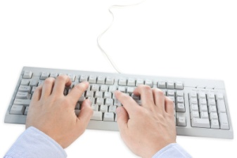
Clean Your Keyboard
Moisten a cotton swab with nail polish remover, and gently dab laptop keys to restore them to their original condition.

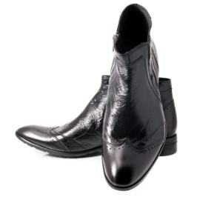
Shine Your Shoes
Saturate a paper towel with nail polish remover, and wipe footwear until any scuffs or stains disappear. Use a damp cloth to remove leftover residue.

Remove Marker Stains
To remove the toughest of permanent ink stains on hands

or walls, drench a cotton ball with nail polish
remover, and then blot the stain away.

Clean Your Razors
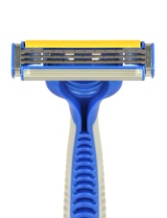
Acetone disinfects, so dunk a razor to sanitize it, then rinse off gunk between the blades as well to make them last longer.

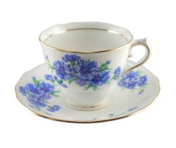
Remove Stubborn Stains From Your China
Soak an old cloth with nail polish remover, then dab coffee- or tea-stained areas; rinse with soap and water.

Avoid decorative patterns, which could be ruined.

http://www.rd.com/slideshows/extraordinary-uses-nail-polish-remover/

